Application Form



Scottish Quality Crops

FIA
Rural Centre, West Mains, Ingliston,
Newbridge, EH28 8NZ

Tel: 0131 609 0558
Email: info@foodassurance.co.uk

Application review carried out by | Date | Undertake requested certification work (if No, record reason)
 |  | YES / NO

Scottish Quality Crops Application Form | Issue 19 Rev 0 | October 2026

The undernoted wishes to apply for registration under the FIA Certification Scheme on behalf of Scottish Quality Crops (SQC).

BUSINESS DETAILS (Note: Business address details will be printed on the grain passports)
Business Name:
Address:

 |  |  | Postcode:
Tel: | Fax: |  | Mobile:
Email: |  | CPH No:

CONTACT DETAILS
Contact Name:
Address:

 |  | Postcode:
Tel: | Fax: | Mobile:
Email:
BILLING DETAILS (if different from above)
Contact Name:
Address:

 |  | Postcode:
Tel: | Fax: | Mobile:
Email:

Have you previously been a member of SQC or Quality Meat Scotland Cattle & Sheep Scheme YES/NO
If YES, please detail your membership No below:

QMS - Cattle & Sheep No: ……….. SQC Mem No: ………..

Does any company within FIA ( https://foodintegrityassurance.co.uk/ ) currently provide you with services? If so, please provide details …………………………

Do you require a copy of the current SQC scheme standard (Updated October 2026) YES / NO
It is a condition of the scheme that all applicants must sign the following declaration that they will abide by the terms of the Scheme.

DECLARATION
I (the undersigned) have read the requirements of the Scottish Quality Crops Assurance Scheme operated by Food Integrity Assurance Ltd (FIA) on behalf of SQC. I am fully responsible for the operation of this unit(s) declared, and hereby wish to apply to join the SQC Scheme.

If accepted I agree to abide by the SQC Membership Rules and certification requirements as detailed in the SQC Standards and FIA Certification Regulations, as amended from time to time.

I declare that I KNOW/DO NOT KNOW (please delete as appropriate and give details if relevant below) of any current, past (within the last five years) or pending prosecutions relating to my business activities at the time of applying for membership of the Scheme. Failure to provide any relevant information may result in refusal or termination of SQC membership.

Details of any prosecution within the last 5 years must be declared below:

…………………………………………………………………………………………………………………………………………………
I agree to undertake to inform FIA immediately if, for whatever reason the requirements of the Scheme can no longer be conformed to. I will notify FIA of any major changes to the company’s business or changes to products prior to these being put on the market.

I agree that the unit(s) will be assessed by an FIA assessor appointed to the Scheme who may be accompanied by an observer if applicable. I understand and agree that my membership details (membership number, business details and approved status) will be circulated to Grain Merchants, Grain Groups and the SQC Website for the purpose of verification of the assurance status of my business.

I declare the information given on this form is correct at time of application.

Signature ……………………………………....................... Position ……………………………………………..

Print Name …………………………………………..………. Date ………………………………………………..
Address | Distance | CPH No | Cereals Stored | Cereals Grown
Address | Distance | CPH No | Cereals Stored | Cereals Grown
Address | Distance | CPH No | Cereals Stored | Cereals Grown
Address | Distance | CPH No | Cereals Stored | Cereals Grown
Address | Distance | CPH No | Cereals Stored | Cereals Grown
Address | Distance | CPH No | Cereals Stored | Cereals Grown
Address | Distance | CPH No | Cereals Stored | Cereals Grown
Addresses of any other farm unit used in conjunction with crop membership: Please tick
Address | Distance | CPH No | Cereals Stored | Cereals Grown
Address | Distance | CPH Number | Cereals  Stored | Cereals  Grown

NB There is an additional charge of £79.12 + £15.82 (VAT @ 20%) = £94.94 for each unit over 15 miles from the main unit.

The annual fee is linked to the size of your crop enterprise as follows:

SQC Membership Only |  |  |  |  | Discounted (if a member of QMS Scheme)
Band | Crop  Area  (ha) | Subscription | VAT @ 20% | Total | Band | Crop  Area  (ha) | Subscription | VAT @ 20% | Total
1 | Up to 76 | £224.15 | £44.83 | £268.98 | 1 | Up to 76 | £212.94 | £42.59 | £255.53
2 | ≥ 76 to 200 | £270.30 | £54.06 | £324.36 | 2 | ≥ 76 to 200 | £256.79 | £51.36 | £308.15
3 | ≥ 201 to 300 | £336.25 | £67.25 | £403.50 | 3 | ≥ 201 to 300 | £319.44 | £63.89 | £383.33
4 | ≥ 301 | £402.17 | £80.43 | £482.60 | 4 | ≥ 301 | £382.06 | £76.41 | £458.47

CALCULATE YOUR SUBSCRIPTION FROM THE TOTAL AREA OF THE FOLLOWING CROPS GROWN |  |  |  | FOR INFORMATION ONLY
CROP | HECTARES | CROP | HECTARES | CROP | HECTARES
Spring Barley |  | Spring OSR |  | Potatoes
Winter Barley |  | Winter OSR |  | Vegetables
Spring Wheat |  | Peas |  | Soft Fruit
Winter Wheat |  | Beans |  | Other
Spring Oats |  | Linseed |  | Other
Winter Oats |  | TOTAL |  | TOTAL
Triticale |  | TOTAL |  | TOTAL

I enclose a direct debit form for: No of Hectares ……………..………… = Total £ ……….

Number of Additional Units @ £79.12 + £15.8244 (VAT @ 20%) = £94.94 per unit: ................= Total £ ……….

VAT Registration Number: 634 9081 30

APPLICATION INSTRUCTIONS

Please complete all details and complete the Direct Debit mandate overleaf.
Return the whole form to: Scottish Quality Crops, c/o FIA, Rural Centre, West Mains, Ingliston, Newbridge, EH28 8NZ Tel: 0131 609 0558

Please do not send payment by cheque.
A VAT receipt will be issued when payment funds are drawn from your account.



 |  |  |  |  |  |  |  |  |  |  |  |  |  | Instruction to your  bank or building society  to pay by Direct Debit
Please fill in the whole form using a ball point pen and send it to:
Scottish Quality Farm Assured Combinable Crops Ltd
c/o FIA
Rural Centre
West Mains
Ingliston, Newbridge
EH28 8NZ
 |  |  |  |  |  |  |  |  |  |  |  |  |  | Service user number
 |  |  |  |  |  |  |  |  |  |  |  |  |  | 8 |  | 0 |  | 7 |  | 8 |  | 8 |  | 6
Name(s) of account holder(s) |  |  |  |  |  |  |  |  |  |  |  |  |  | Reference (Please insert your membership number)
Instruction to your bank or building society
Please pay Scottish Quality Farm Assured Combinable Crops Ltd Direct Debits from the account detailed in this Instruction subject to the safeguards assured by the Direct Debit Guarantee. I understand that this Instruction may remain with Scottish Quality Farm Assured Combinable Crops Ltd and, if so, details will be passed electronically to my bank/building society.
Bank/building society account number
Branch sort code
Name and full postal address of your bank or building society
To: The Manager |  |  |  |  | Bank/building society
Address |  |  |  |  |  |  |  |  |  |  |  |  |  | Signature(s)
 |  |  |  |  |  | Postcode |  |  |  |  |  |  |  | Date
Banks and building societies may not accept Direct Debit Instructions for some types of account 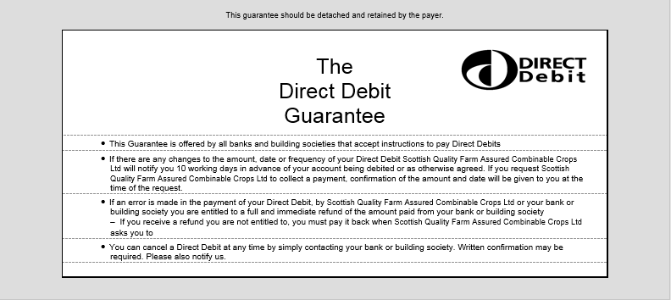
DDI2

